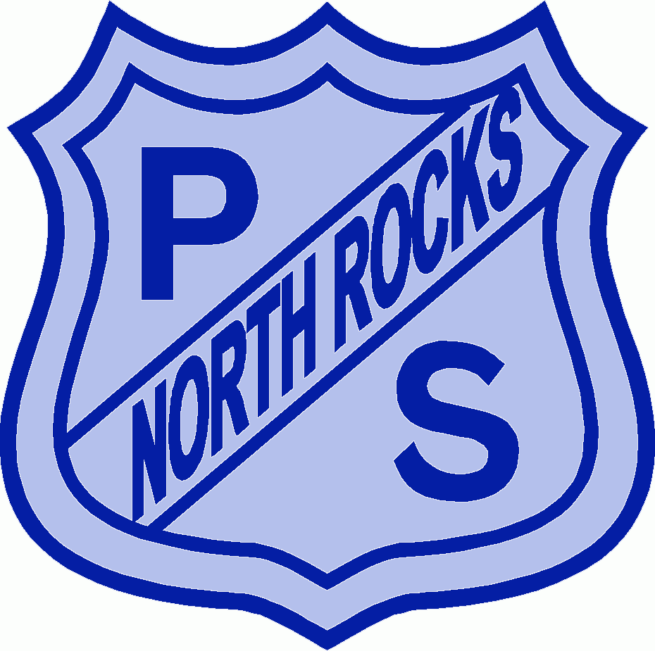
359 North Rocks Road Phone: 9871 1772 North Rocks NSW 2151 Fax: 9872 1448

Email: northrocks-p.school@det.nsw.edu.au

North Rocks Public School

24 March 2023

Special Religious Education and Special Education in Ethics Participation Letter

A feature of the public education system in NSW is the opportunity to provide time in class for education in ethics, faith and morality from a religious or non-religious perspective at the choice of parents.
The school website, https://northrocks-p.schools.nsw.gov.au/ provides information on these options to support parent/carer choice.
A parent/carer may at any time notify the school in writing that they wish to change their decision. Students will continue the same arrangement as the previous year unless a parent/carer has requested a change in writing.
For more information about Special Religious Education (SRE) and Special Education in Ethics (SEE), including the list of approved providers, please visit: https://education.nsw.gov.au/teaching-and-learning/curriculum/learning-across-the-curriculum/religion-and-ethics
If your preferred SRE or SEE option is not available, please contact the approved provider. Students not attending SRE or SEE are given supervised alternative meaningful activities.
The following options are available at North Rocks Public School. Please choose one:
SRE Options
□ Option 1: Protestant
□ Option 2: Catholic
□ Option 3: Islamic
OR
□ Please check this box if you do not wish for your child to attend SRE. Your child will participate in alternative activities.
SEE Option - If you have declined for your child to attend SRE above please check below if you would like your child to attend SEE.
□ Special Education in Ethics
Student name: Year:
Signature of parent/carer: Date:
Principal – Mr Robert Ieroianni
Scripture and Ethics Coordinator – Mrs Lisa Kent
Please return to your child’s class teacher

